We’ve made an integration with Slack by following the instructions and link specified in IBM Watson Assistant website (See below screenshot)

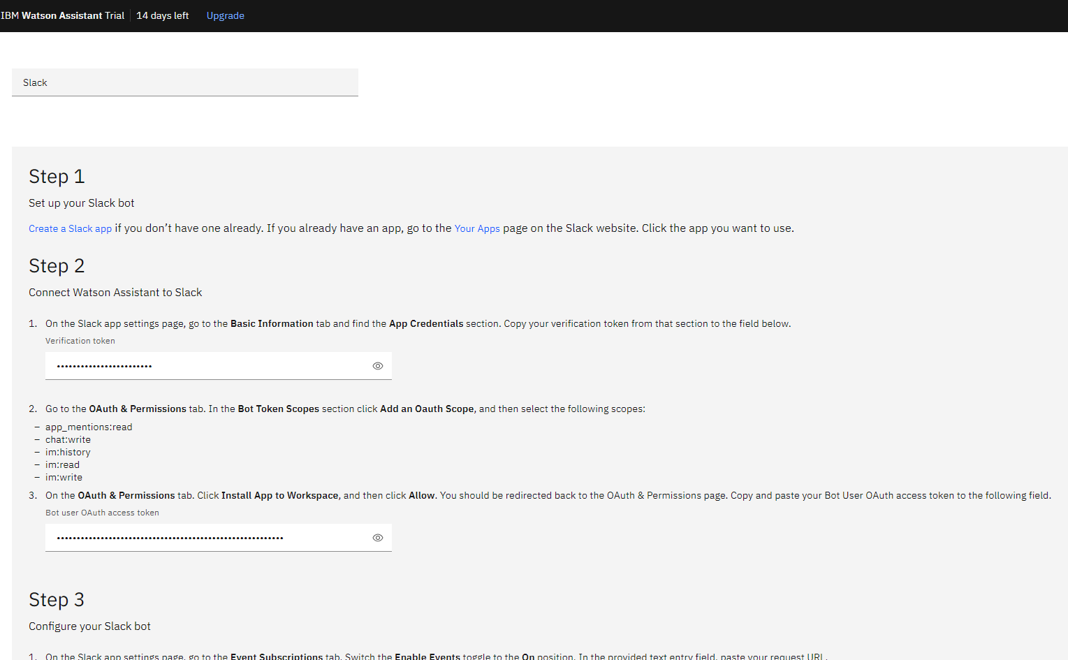

We’ve also built the chatbot as a slack app using the following link: [Create a Slack app](https://api.slack.com/start)

Teleri is available on Slack in the workspace which we created. Please join us and enjoy chatting with Teleri by clicking [here](https://join.slack.com/t/team-asambd/shared_invite/zt-q32y97c7-Hl1gzJRqRjT8TRrGQDzJ9Q)

She, Teleri, can also be added to other Slack workspaces upon request

